What can you learn from a personalized test?
Analyzing Stanford-Binet, Myers-Briggs, and Johnson O’Connor
By Jonas Jacobson
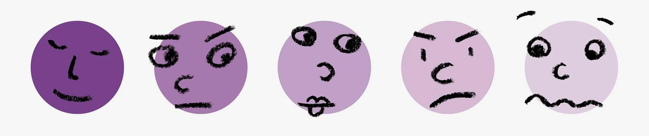
December 3, 2020
Over the course of our lives, we take many standardized tests. There are required tests, like the ACT or SAT, and there are optional tests, or the ones we opt to take on our own. The tests we pursue by our own choosing are usually the ones claiming to tell us a great deal about ourselves. Are you intelligent? What kind of personality are you? What skills do you possess? And most importantly, how do your results compare with the people around you? Simply take a specific written, oral, or practical skills test and you can find out.
Now here is where I come into the picture; a senior at a liberal arts college whose only career plans are riddled with unknowingness. My English major and Economics minor serving as representations of my well-roundedness and inability to specialize. What is in fact clear is that any moment of clarity will not arise until I put myself out there and try a variety of professions. However, this is not an entirely helpful idea when I need to distinguish one profession as the first step on the journey. Could a personalized test direct me towards this first step?
This thought spurned a larger consideration of standardized testing in general. If a personalized test could grant you an improved understanding of yourself, then they could potentially contribute to greater happiness whether in your work, career building, or even personal life. Or, on the other hand, maybe the additional knowledge could frustrate or inhibit you in those areas. While everyone may have a different experience with these tests, larger conclusions can still be drawn about what certain personalized tests can tell you about yourself.
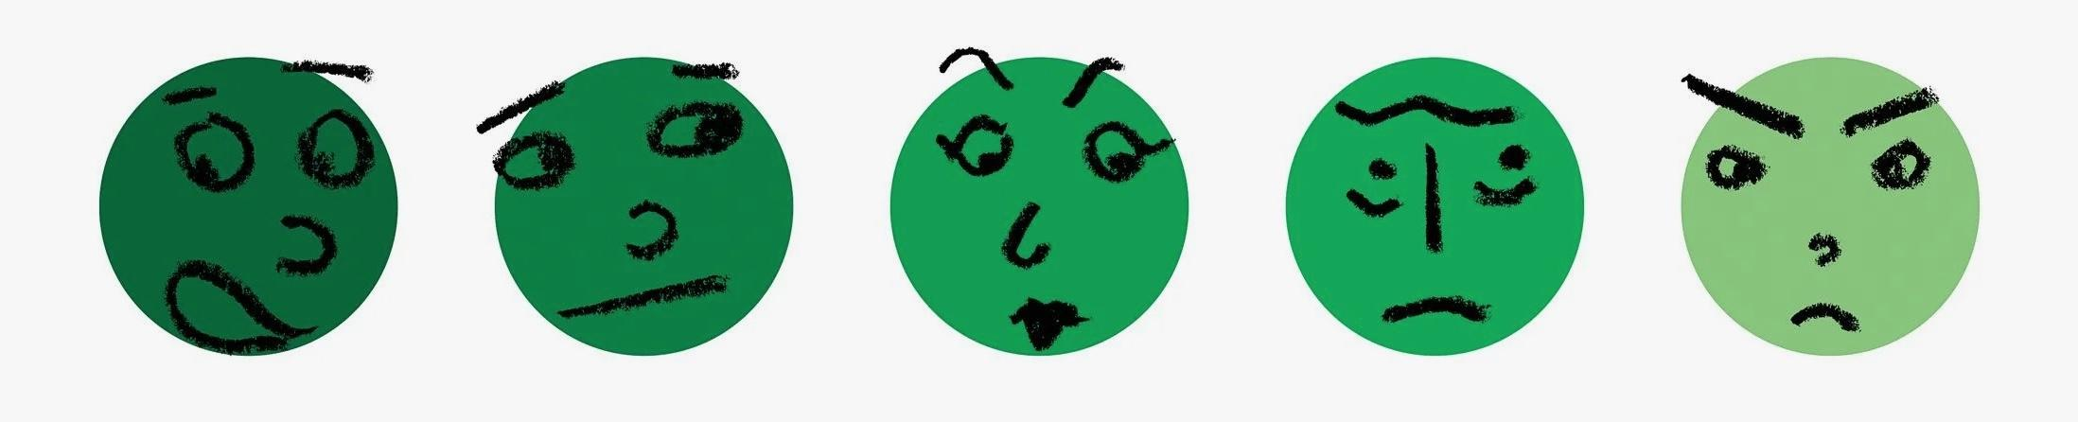
In order to dive deeper, I analyzed three different tests that all claim to inform the test taker about a specific category: the Myers-Briggs Type Indicator for personality; the Johnson O'Connor Aptitude Test for skills; and the Stanford-Binet Test for intelligence. Since these tests prescribe different outcomes and are appealing at differing moments in your life, they can be hard to compare. But, hopefully, by the end of this article, you will have a heightened understanding of the personalized tests and you will know which tests would be beneficial for you to explore alongside your pursuit of happiness.
Since its development nearly 100 years ago, the Stanford-Binet (SB) has sought to measure an individual’s general intelligence. The SB should not be equated with one of the IQ tests you stumble upon and take online. The test is usually administered by a professional and licensed to that professional by Stanford-Binet or one of the other major test publishing companies. Recent editions of the SB, such as the fourth and fifth edition, include factors beyond simply general intelligence.
The five factors measured by the current edition, recognized as the SB5, include the following: Reasoning, Knowledge, Quantitative Reasoning, Visual-Spatial Processing, and Working Memory. All of the factor scores have a mean score of 100. A composite of the scores on these tests is taken, and that number is considered to be the final measure of intelligence. The number from the results is supposedly a strong statistical predictor of multiple future life outcomes - income, education level, health, even longevity.
While the SB is a strong measure of general intelligence and one of the strongest indicators of future success for a group of people, the test is also a weak indicator of future success for an individual in particular. That is to say, just because you have a high IQ score does not mean that you will necessarily be successful. Additionally, there is an implicit bias given the fact that most people know IQ as the online version. The bias is fairly justified as a singular number, even with context, does not really tell you much about a person.
I had, David Thole, one of my roommates, take an online replicate of the test on a website called stanfordbinettest.com. This was not his first time taking IQ tests; he engaged with some for fun during his free time in high school. He found the questions to be simple and straightforward with a high amount of math and logic based questions.
Even though he enjoyed the test in a competitive nature as a break from his rigorous chemistry assignments, he questioned how everything was related to IQ. Some of those issues revolved around the ability to improve your score through test practice which he saw as counterintuitive to what the SB was hoping to tell him about himself. As a result, he was intrigued by the SB5 edition since it offers more descriptive results and tests concepts beyond general intelligence.
I may fall into the bias of the online tests, but I believe the SB5 is still too similar to its earlier days of solely measuring general intelligence. The early days refer to mid-century schemes in order to organize and manipulate people by reducing them to numbers. Given the SB’s constraints, on a personal level, there does not seem much of a point in taking the test other than for trivial, personal curiosity.
Typically, you will take an IQ test such as the Stanford Binet as a way to quantify your smartness. And usually your results will go one of two ways: you will be pleased and receive an ego boost or you will be disappointed and thus demoralized. The reality is that neither of these outcomes will have a lasting effect on any aspect of your life because your SB score is not what defines success. This point is at the heart of why the test is a weak indicator of future success for an individual.
For David, there has to be more constructive ways that he can exercise his competitive nature. Similarly, there has to be tests out there that include more personalized factors and give you more descriptive results than general intelligence. Intelligence as derived from a numerical score, in the long run, will not lead to happiness.

Katharine Briggs and Isabel Myers, a mother and daughter duo, invented and commercialized the Myers-Briggs Type Indicator (MBTI), the most popular personality test in the world, after 80 years of work. Since neither of them had any professional training in psychology, it was essentially a home cooked idea that arose out of domestic circumstances, where even minor differences in personality can be strongly magnified.
The MBTI is supposed to indicate the type of personality with which you have been born. With this knowledge, the test hopes to help with people sorting and self-discovery. Your result is the combination of four characteristics indicated by your responses to ninety-three multiple choice questions. Everyone is either extroverted or introverted, sensing or intuitive, thinking or feeling, and judging or perceiving. These attributes are usually abbreviated to form a four letter combination out of the sixteen possible personality types.
The dichotomy between extraversion and introversion refers to the tendency for a person to be energized by outwardly focused behavior or inwardly focused behavior. Thinking utilizes pragmatism and logic; feeling values others' points of view. Sensing involves a person utilizing their five senses for perception, while intuition involves evaluating impressions and patterns of the world. The last dimension, judging or perceiving, involves whether a person prefers planning or spontaneity, respectively, and signals which of the functions are dominant.
For a solid majority of people in the world, their experience with the MBTI has been a positive one. There is absolutely an appeal for an instrument that can take stock of your personal interests and abilities. Specifically, personality assessments such as the MBTI are highly effective for use in individual and team development. Some people have even reported that they felt liberated after finding out their type; it helped them cope with their work or with their marriage and it empowered them to be themselves.
Since the early 1980s, incoming Davidson students have taken the MBTI assessment as a tool for roommate pairing. Parker Conquest, another one of my friends here, took the test a few times before Davidson and is fascinated by the idea of taking personality into scientific measurement. Even though he is not close with his freshman year roommate now, he would describe their pairing as one that worked well. He wishes that Davidson would disclose their choices behind how they use the MBTI to pair students.
Still, in many ways, the MBTI is not perfect. First, the assessment is in no way, shape, or form scientific. More than half the people who take it a second time get a different score. And in the aggregate, most test-takers fall between the binaries. If you are a polarizing characteristic, there is a high chance that you already knew that about yourself. Some of the characteristic differentiations are not actual dichotomies which demonstrates internal contradictions in the assessment.
Most significantly, the test is entirely self-reported. As a result, you could be influenced by your mood or even what you, potentially falsely, think about yourself. Quite simply, the MBTI is unlikely to be a scientific or valid measure of your entire personality. One expert even compared the assessment to an astrological sign.
Erroneously thinking that the true self has been revealed through the MBTI could lead to a negative outcome because you could stop using the other characteristics of which that test does not describe you. You can waste a lot of energy and bring on a lot of psychic pain if you think of personality type differences as incompatibilities that have to be ironed out. If there is no link to improvement, then a lack of results following the MBTI may further frustrate someone who is trying to develop themselves.
I already took the MBTI multiple times and my score tends to be ENFJ or ESFJ. At face value, these four letters are not entirely representative of who I am. Furthermore, the fact that I am listing two different traits shows how I do not receive the same score every time. Still, I find my extraversion score helpful to point to at times given my shy nature at first. The feeling score, even though it is close to the halfway point of thinking, is also interesting because it is not what I would have expected to obtain. Most importantly, the MBTI I took before my freshman year set me up with an amazing roommate who I am still close with today.
Given the test is easily accessible, I would not advise anyone against taking the MBTI. An increased self-awareness for you can be super helpful for your career. It helped Parker and I realize we were more extroverted than we thought and the same moment of greater understanding could happen for you. Regardless, I would caution you to not see personality type differences as incompatibilities and to be aware of the inherent contradictions within the test. Companies may be able to use the test in the best way possible because they can form balanced teams and they can encourage employees not to look too deep into their score.
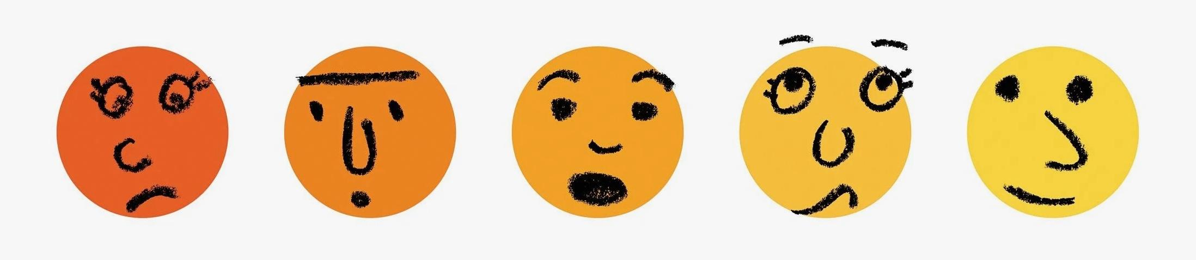
The Johnson O’Connor Aptitude Assessment, perhaps the least known of the three tests, is administered by the Johnson O'Connor Research Foundation, Inc., which grew from a testing program from 1922 for the General Electric Company in Massachusetts. Since then, hundreds of thousands of people have used the Research Foundation’s aptitude testing service to find direction in educational and career planning. Their approach to understanding the individual has continued to evolve over the last eighty plus years.
Through the Johnson O’Connor Assessment, you can learn about your particular set of natural traits which the Research Foundation refers to as aptitudes. Aptitudes are talents, based on heredity, for doing, or learning to do, certain kinds of things easily and quickly. They have little to do with knowledge or culture, or education, or even interests. Instead, these are skills with which you are born. Every occupation, whether it is engineering, medicine, law, or management, uses certain aptitudes. The work you are most likely to enjoy and be successful in is work that uses your aptitudes.
Johnson O’Connor’s tests are not multiple choice like many other personalized tests, but instead are more like puzzles or games. You are asked to do a wide variety of tasks like assembling blocks, recalling designs, moving chips into order, and listening to simple tunes. The results on these tests correlate to around 25 definable aptitudes. Unlike an IQ score, your aptitude test results form a pattern, showing your various strengths and weaknesses; two people can have identical IQ scores but very different aptitude patterns.
One word that describes the Johnson O’Connor assessment is extensive. The test is administered over multiple hours at one of the ten locations across the United States. One diverging benefit when compared with the SB and MBTI is that the Johnson O’Connor assessment is not self-reported. There is one-on-one help, guided reflection, and a 60 to 90-minute session with a trained aptitude consultant to go over the results in detail. Often, people will report that they feel more optimistic about their future career possibilities at the end. Yet, similar to the MBTI, the aptitudes are not about passing or failing because all of them provide information.
My father, Peter Jacobson, took the assessment around 30 years ago in New York City. He acknowledged that the test makes you conscious of all of the different aptitudes that exist and how the test is self-reflective because you consider your talents. He was high in ideaphoria, the ability to come up with many ideas quickly, and foresight, or the ability to stick to long term goals. As it turns out, he was a stock broker for a short while, which turned out to be a bad spot because the occupation conflicted with his aptitudes. Now, as a food entrepreneur, both of these aptitudes fit his career incredibly well.
One of the main concerns with the Johnson O’Connor assessment is accessibility. The test currently costs around $800 and that does not include travel to one of the locations. Still, this is a mere fraction of what people will pay for higher education. Additionally, there is a risk that the Johnson O’Connor assessment could discourage someone from pursuing a passion for which they may not have a strong aptitude. Of the many people that Peter has recommended the test to, not all of them have had positive experiences. A competitive person could be demoralized by a score that does not match up with expectations. This frustration can be magnified by the fact that aptitudes remain stable throughout life.
Taking my father’s advice for years, I am planning on completing the Johnson O’Connor assessment and I am eagerly anticipating it. I know that I need to go in with a growth mindset because it is rather crucial that you do not elicit a stubborn or competitive mentality. The assessment will indicate how you are talented in so many different ways, but instead show you what you have skills in based on genetics. Also, hopefully, the aptitude tests will not discourage you from pursuing a true passion if it is not a strong skill.
Whether or not you are in a moment - like me - where you need to make a career decision, the Johnson O’Connor assessment can still help you better understand your natural skills and which careers you are predisposed to enjoy. The Johnson O’Connor Research Foundation really drives home the point that knowledge is power. Instead of offering career advice, all they can do is point you towards careers that fit the aptitudes in which you are strong.
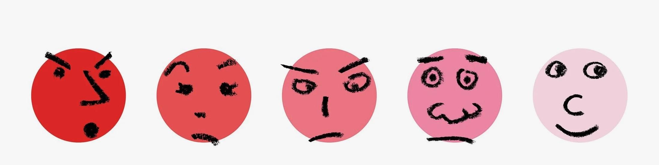
At this point in the article, I have now gone through all three personalized tests. All have their positives. The SB can be quite beneficial for early childhood measures of giftedness. Similarly, the most recent edition of the test strives to report a conclusion that is deeper than a mere numerical conclusion of general intelligence. On the other end, the MBTI is an extremely popular personality test that is unbelievably well received as an instrument that can take stock of your personal interests and abilities.
Out of all three, I am the most excited by the Johnson O’Connor aptitude assessment. This intrigue is in a large part a result of a career focused test coming at a time where my career decision hangs over my head. In no way do I believe that, if I take the assessment, I will leave the Johnson O’Connor research testing facility with an exact idea of what I should pursue as a career. Instead, my aptitudes will be another tool in my toolbox. Just like the SB test, my aptitudes will not directly determine my success because the most important concept is hard work and determination.
One similarity between all three tests is that your result or outcome tends to remain stable throughout your whole life. From a scientific standpoint, this is a winning concept. If your score was highly variable then it would be almost impossible to recognize and analyze. On the other hand, from a personal growth perspective, the idea that you are stuck with these attributes is not by any means an inviting idea. Inherently, the fixedness is contradictory with the all important concept of using a growth mindset in life. Knowing yourself is important, but there is something unsettling about this self being rigid and unmovable.
The significant risk of all personalized tests is not in the design, but in your response to the result. It is hard to knock the test design because there is around a hundred years of research for each. On the other hand, your reaction is more dangerous because the only explanation behind it is like handing out snacks after lunch: “you get what you get.”
On this front, an intelligence score seems the most daunting because there is not the same idea that no one test is better than another like with the MBTI and Johnson O’Connor assessment. Nonetheless, there is always a similar risk with those two tests that you are not satisfied with your result. In most cases, this risk is all that lies as an obstacle with a direct link between personalized tests and happiness. Understanding yourself should always be important - and even more so at various points in your life - but it is difficult to properly use this information when you are frustrated by it.
As Kid Cudi declares in his song Up Up & Away, “The end is never the end. A new challenge awaits. A test no man could be prepared for. A new hell he must conquer and destroy. A new level of growth he must confront himself.” Even though the result of a personalized test may be final; what David, Parker my dad, or you use that information for is ever growing. There is no way to know what the test of life will bring, but applying your added understanding of yourself to areas of passion can surely help.

Bibliography
Amlen, Deb. “What the Heck Is That?” The New York Times, 11 Mar. 2019,
www.nytimes.com/2019/03/11/crosswords/what-the-heck-is-that-iqs.html.
“Aptitude Assessment.” Johnson O'Connor Research Foundation, 2020, www.jocrf.org/testing.
Bowman, Kyle. “My Experience With the Johnson O'Connor Aptitude Testing.” Pretty Good at
Life, 9 Aug. 2010, prettygoodatlife.wordpress.com/2010/08/09/my-johnson-oconnor-
occupational-experience/.
Campbell, Sue. “How Aptitude Testing Helps Mid-Lifers.” Forbes, Forbes Magazine, 22 July
2015, www.forbes.com/sites/nextavenue/2015/07/22/how-aptitude-testing-helps-mid-
lifers/?sh=57d5037ac8e3.
DiStefano, Christine, and Stefan C. Dombrowski. “Investigating the Theoretical Structure of the
Stanford-Binet-Fifth Edition.” Journal of Psychoeducational Assessment, vol. 24, no. 2, June 2006, pp. 123–136, doi:10.1177/0734282905285244.
Jacobson, Jonas, and David Thole. “Stanford Binet Test Interview.” 4 Nov. 2020.
Jacobson, Jonas, and Parker Conquest. “Myers-Briggs Type Indicator Interview.” 4 Nov. 2020.
Jacobson, Jonas, and Peter Jacobson. “Johnson O’Connor Aptitude Assessment Interview.” 3
Nov. 2020.
Magnusson, Peter. “Is IQ A Predictor Of Success?” Forbes, Forbes Magazine, 16 Sept. 2015,
www.forbes.com/sites/quora/2015/09/16/is-iq-a-predictor-of-success/?sh=14472a6e3604.
Menand, Louis. “What Personality Tests Really Deliver.” The New Yorker, 10 Sept. 2018,
www.newyorker.com/magazine/2018/09/10/what-personality-tests-really-deliver.
Moyle, Penny, and John Hackston. “Personality Assessment for Employee Development: Ivory
Tower or Real World?” Taylor and Francis, Journal of Personality Assessment, 31 Aug.
2017, www.tandfonline.com/doi/abs/10.1080/00223891.2018.1481078?journalCode=
hjpa20.
Newton, Jocelyn H., et al. “Assessing Giftedness in Children: Comparing the Accuracy of Three
Shortened Measures of Intelligence to the Stanford-Binet Intelligence Scales, Fifth Edition.” Psychology in the Schools, vol. 45, no. 6, July 2008, pp. 523–536. EBSCOhost, doi:10.1002/pits.20321.
Stein, Randy, and Alexander B. Swan. “Evaluating the Validity of Myers-Briggs Type Indicator
Theory: A Teaching Tool and Window into Intuitive Psychology.” Social and Personality
Psychology Compass, vol. 13, no. 2, Feb. 2019. EBSCOhost, doi:10.1111/spc3.12434.

